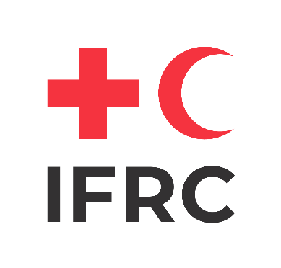
Name of NS leadership or NSD Director
Title
Name of National Society
Name of Trainer
Title
Name of Organsiation
First name, Last name
Completed

Branch Organizational Capacity to Act (BOCA) Training of Facilitators (ToF)

Course organised by

[Name of National Society of IFRC Office]

Name of Location [City], [Country] from [Date] to [Date] [Month] [Year]

This is to certify that

